Project 4 | Concordance

A concordance is an alphabetical list of the principal words used in a book or body of work, listing every instance of each word with its immediate context. Only works of special importance have had concordances prepared for them, such as the Bible, Qur'an, the works of Shakespeare, or classical Latin and Greek authors, because of the time, difficulty, and expense involved in creating a concordance in the pre-computer era.

The first Bible concordance was compiled for the Vulgate Bible by Hugh of St Cher (d.1262), who employed 500 monks to assist him.

The reconstruction of the text of some of the Dead Sea Scrolls involved a concordance.

Assignment
Write a program that creates a concordance from some text. It will list all the words in alphabetic order followed by a list of line numbers where the word can be found in the text.

Academic Honesty Policy Reminder | Do your own work – each submitted project will be compared against other submissions from current and previous semesters.

Specifications

Data Element - ConcordanceDataElement
ConcordanceDataElement implements Comparable<ConcordanceDataElement> and consists of a String (the word) and a reference to a LinkedList<Integer> (list of line numbers where word occurs). See provided Javadoc.

Data Structure - ConcordanceDataStructure
Implement the data structure as specified (ConcordanceDataStructureInterface).

You will be implementing a hash table with buckets. It will be an array of linked list of ConcordanceDataElements. The add method will take a word and a line number to be added to the data structure. If the word already exists, the line number will be added to the linked list for this word. If the line number for the word already exists, don’t add it again to the linked list. (i.e., if Sarah was on line 5 twice, the first line 5 would be added to the linked list for Sarah, the second one would not). If the word doesn’t exist, create a ConcordanceDataElement and add it to the HashTable. Two constructors will be required, one that takes in an integer that is the estimated number of words in the text, the other is used for testing purposes.

Data Manager - ConcordanceDataManager
Implements the data manager as specified (ConcordanceDataManagerInterface).

The data manager allows the user to create a concordance file or a concordance list (ArrayList of strings). The input is read (from a file or string) and is added to the data structure through the add method. The add method requires a word and a line number. The line number is incremented every time a newline appears in the file or the string. Change all words to lowercase so that Now and now are considered the same word.

Exception Classes
IOException – created and thrown when user selects an input file that cannot be read (check out the methods of File).

GUI (provided)
- User will only create a concordance file once they have entered an input file and an output file
- Show the text area only when the option to create from text is chosen
- Use a FileChooser to select the input and output files. Use a filter so that user can only select .txt files
- Inform the user if there is an error with the input file or the output file
- Use exception handling for the validity of the files
- If creating a concordance from text, make sure the user has entered some text in the text area. Inform user if text area is empty
- Display the concordance from the text in the text area
- Provide a way for the user to “clear” the text area

Testing
- Create a JUnit Test – ConcordanceDataManager_STUDENT_Test

Additional Details
There are two ways to create a concordance. The first requires a document to be read from an input file, and the concordance data is written to an output file. The second reads the input from a string and returns an ArrayList of strings that represent the concordance of the string.
Don't include the words "the" or “and” in your concordance since they are so common. Also, do not include words that have length less than 3. Strip out all punctuation, except apostrophes that occur in the middle of a word (i.e., let’s, we’d, etc.)
Programming Concepts

This project utilizes the following concepts:
- Hash Table
- Link List
- Hash code, buckets/chaining
- Exception handling
- File Chooser
Write-up & Submission Requirements
Review the provided rubric to understand project expectations, including documentation, CMSC204, and programming requirements. Two artifacts MUST be submitted for this project: Java source code and a write-up.
At a minimum, the write-up needs to address -
- Approach, design & algorithm
  - DO NOT start coding your project immediately! Come up with a high level design for the project first
    - What’s your game plan to complete the project?
    - Break the project into smallest modules where applicable
    - UML diagrams will go a long way
  - Each student is welcome to expand on the design, if it makes sense. Students will not be penalized for going “above and beyond” specifications of the project
  - Complete this step first, then write your code
- Test Plan & Test Cases
  - Ensure that your project can successfully pass all provided “public test cases.” What other test cases have you attempted?
    - Students should think about potential private tests – what would they be?
  - Your instructor will test your project using an additional set of private test cases as well as the provided public test cases
  - I want to see your “thinking,” in particular, how you are testing your program
  - Each submission should be rock solid, with no bugs
  - Capture screenshots of your test runs in your write-up as you run them
- Highlight your learning experience and lessons learned
  - I am very interested to learn about what you have done, how you did, etc.
- Anything else that you want to share with me
- Take a screen shot of the repo with the directory and files
- If your project is not working as expected, submit it as-is but clearly articulate your situation in your write-up in order to potentially receive partial credit

Each student must submit one compressed (.zip) file back to the Assignment (link) with the following deliverables:
- Your entire Eclipse project folder (Source code included)
- Write-up as a Word or PDF file, one write-up per project
- I WILL compile, run and test every submission using a set of public and private test cases – this is how I test to ensure that your project is working correctly
- Name the compressed file (zip format) as <lastname>_project_x
  - where x is the project number and your last name (e.g. Thai_Project_1.zip)
- Double check your submission, as I can only grade what’s being submitted (don’t assume anything)
- DO NOT email your submission! It won’t be accepted

Not clear? That’s okay, but do ask your questions. “I did not know” or “I did not understand” is not good enough.

Start working on each project immediately so that we can discuss any concerns or questions you have. Reminder – I am unavailable on Saturdays and have limited availability on Sundays.
Sample Test Cases & Outputs (Consider them as examples only)

Creating a Concordance from an input file

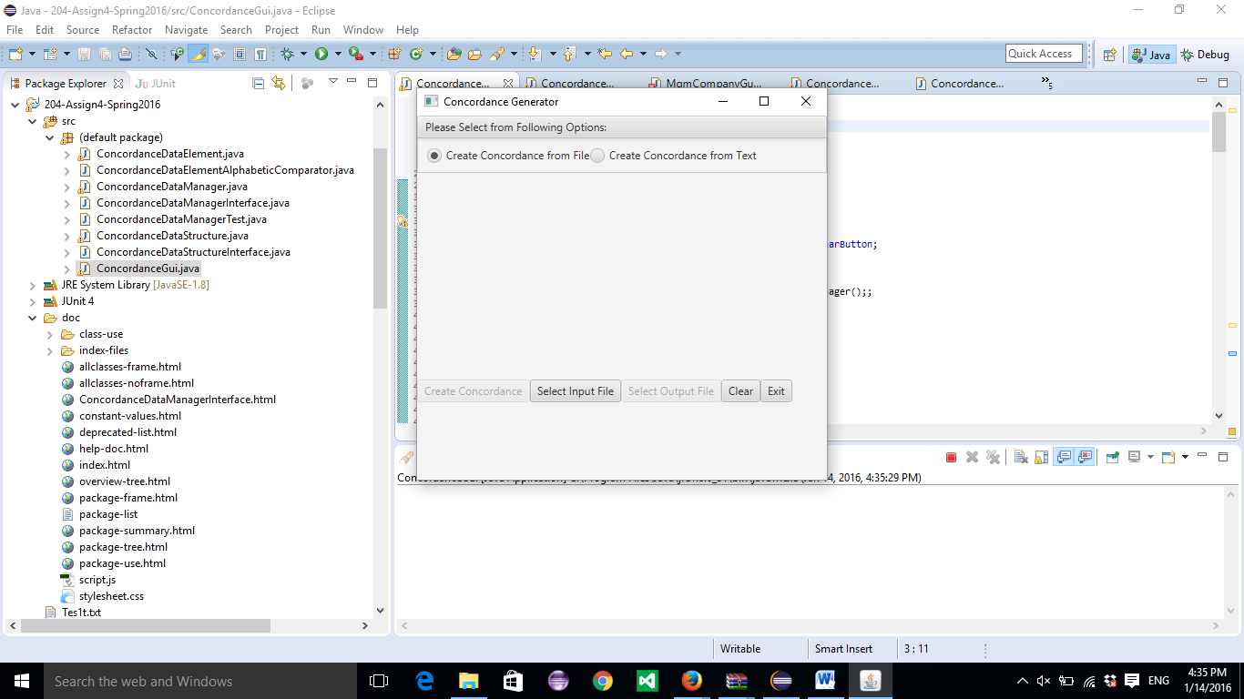

Select an input file and an output file. PrideAndPrejudice.txt was used.
Sample of output file:

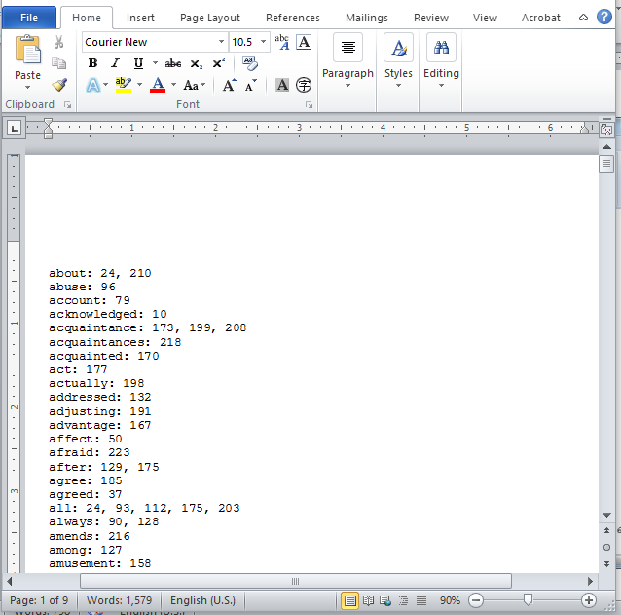

Creating a Concordance from text:

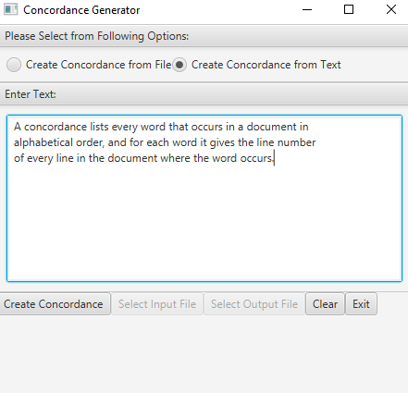

Using “Create Concordance” button displays Concordance in text area

